Abstract and Concrete Classes

Lane Dorscher
CS300-T301 Programming Languages (2261-1)
Bellevue University
10/12/2025
Ahmad Mostafa

Introduction
This paper will highlight the differences between abstract and concrete classes in Python. A class is often referred to as a blueprint for an object, describing the attributes and behaviors it can have. An abstract class is a blueprint for other classes, meaning it defines methods that must be implemented but does not provide complete behavior itself. Abstract classes cannot be instantiated directly; they are intended to be inherited by concrete subclasses that provide full implementations. A concrete class is the fully implemented version of the abstract class, capable of being instantiated and used in a program. The purpose of this exercise is to explore how an abstract class functions, what happens when it is used incorrectly, and how concrete subclasses implement its methods to create functional code (Python Software Foundation, 2025).

Abstraction in Action
In the code provided, there is an abstract Student class with a single abstract method called take_test. The method exists only as a signature, without performing any action within the abstract class itself. This design ensures that any subclass of Student must provide its own version of take_test. Attempting to create an instance of the abstract class directly results in a TypeError because Python enforces that all abstract methods must be implemented before instantiation (Python Software Foundation, 2025). This ensures that the abstract class serves solely as a template and cannot exist independently. The screenshot below shows the error generated when attempting to instantiate Student:
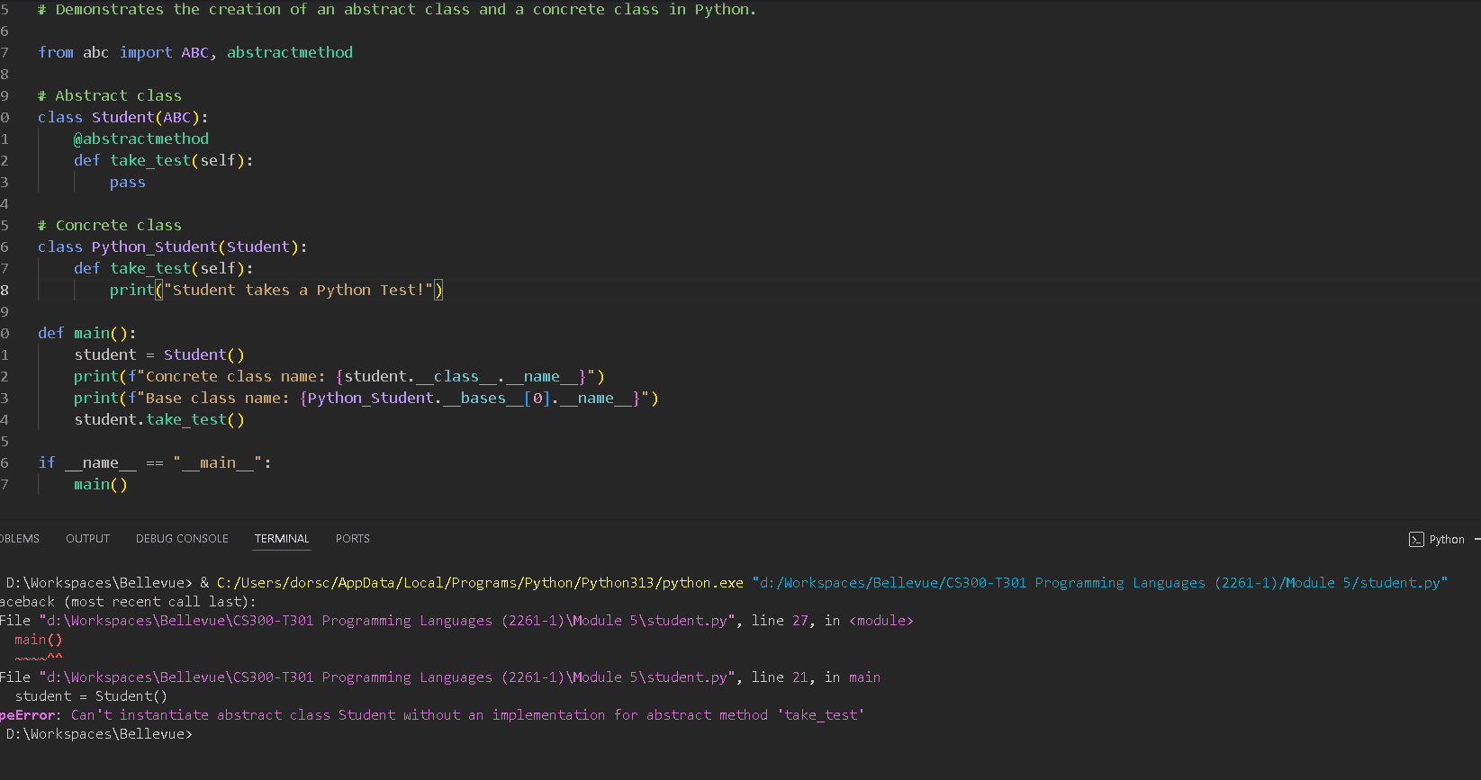
By requiring subclasses to implement abstract methods, Python ensures that all concrete versions of Student share a consistent interface while allowing each subclass to define its own behavior.

Concrete in Action
Once a concrete subclass is created, such as PythonStudent, the take_test method is implemented, allowing instances of the subclass to be created and used. This demonstrates the intended use of abstract classes: providing a structure that subclasses follow while leaving the specific implementation up to each subclass. Concrete classes fulfill the abstract blueprint, enabling the program to execute correctly and take advantage of object-oriented design principles like inheritance, code reuse, and interface consistency. Using this subclass, an object can be instantiated, and its methods are called without errors:
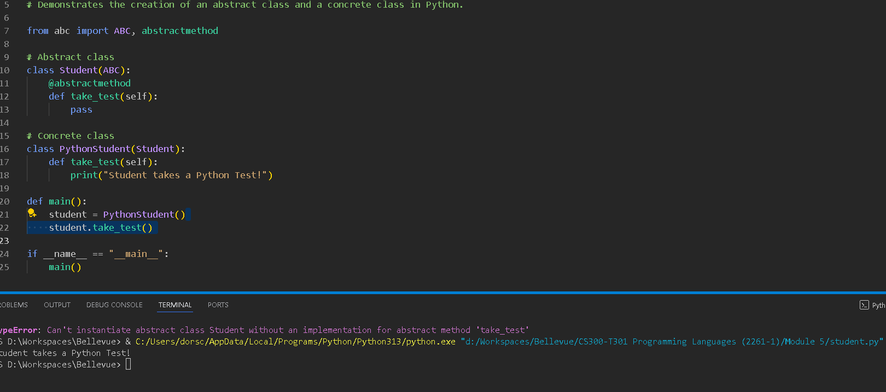

Conclusion
This experiment highlights the key differences between abstract and concrete classes. Abstract classes cannot be instantiated and exist to define required methods, while concrete classes provide full implementations that can be used in a program. Attempting to use an abstract class directly results in a runtime error, which can be resolved by creating a concrete subclass that implements all abstract methods. Abstract classes are valuable for enforcing consistent interfaces across multiple subclasses while allowing flexibility in how those methods are implemented (Python Software Foundation, 2025).

References
Python Software Foundation. (2025). abc — Abstract Base Classes. Retrieved from https://docs.python.org/3/library/abc.html

